ASCII / Images
Write the word "Elf" in binary encoded ASCII. Look up letters from web (CS160Reader Ch 4.9) make sure to pay attention to capital vs. lower case letters:
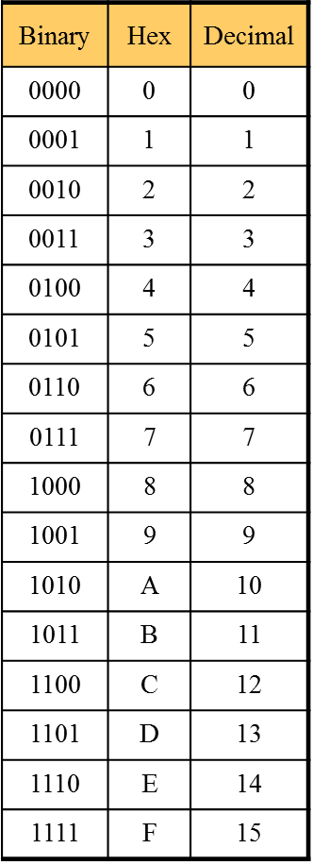
Hex practice
Convert Binary Hex
1011 10001111 0011110000001110

Convert Hex Binary
62 FF A0

4096 | 256 | 16 | 1
Convert the following Hex numbers to Decimal:
2E 15 3F6

128 | 64 | 32 | 16 | 8 | 4 | 2 | 1

Fill out the table by filling in missing blanks:
Decimal | Binary ( use 8 digits ) | Hex (use two digits )
63
 | 00101001
 |  | 4C

Break these hex color codes into their component parts and write each as a decimal number. Then describe the color.
Hex: FFFFB9 Red: Green: Blue:
Description:

Hex: E96519 Red: Green: Blue:
Description:
Binary math practice:

Add these binary numbers. Check your work by converting the starting values and answers to decimal:
A) B) C)
1010 0011 0111
0001 1001 1010

Which problems would have overflow errors if we could only use 4 bits for the answer?

Multiply the following binary numbers. Check your work by converting the starting values and answers to decimal:

0011 0101
0010 1001

